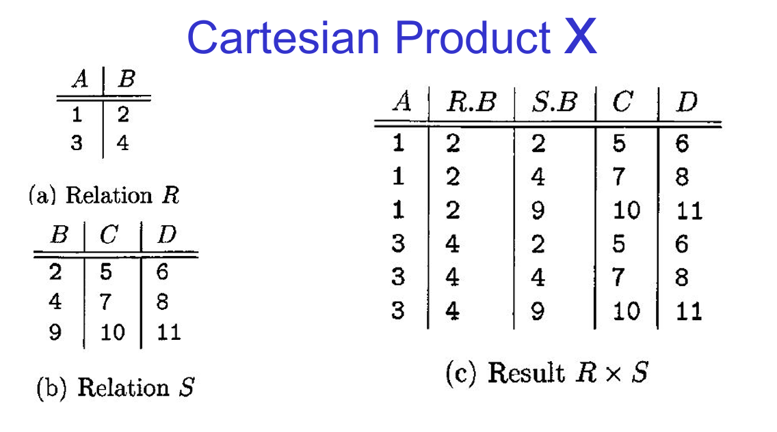

Question 1: Cartesian Product
Given the following relations R and S, compute the Cartesian product R×S.

Relation R
A | B
1 | 2
3 | 4

Relation S
B | C | D
5 | 6 | 7
8 | 9 | 10

Result R×S
Compute the Cartesian product and display the resulting relation.

Question 2: Cartesian Product with Different Attributes
Given the following relations R and S, compute the Cartesian product R×S.

Relation R
X | Y
1 | 2
3 | 4

Relation S
Y | Z | W
2 | 5 | 6
4 | 7 | 8

Result R×S
Compute the Cartesian product and display the resulting relation.

Question 3: Cartesian Product with Larger Relations
Given the following relations R and S, compute the Cartesian product R×S.

Relation R
A | B
1 | 2
3 | 4
5 | 6

Relation S
B | C | D
2 | 5 | 6
4 | 7 | 8
6 | 9 | 10

Result R×S
Compute the Cartesian product and display the resulting relation.

Explanation of Concepts in the Questions
- Cartesian Product (×): Combines each tuple from the first relation with each tuple from the second relation, resulting in a new relation with all possible combinations.
- Attributes: The columns in relations. The resulting relation from a Cartesian product will have attributes from both input relations.
- Tuples: The rows in relations. The number of tuples in the resulting relation is the product of the number of tuples in the input relations.

Question 1: Natural Join
Given the following relations RR and SS, compute the natural join R⋈SR⋈S.

Relation RR
A | B
1 | 2
3 | 4

Relation SS
B | C | D
2 | 5 | 6
4 | 7 | 8
9 | 10 | 11

Result R⋈S
Compute the natural join and display the resulting relation. Explain why the third tuple of SS does not appear in the result.

Question 2: Natural Join with Different Attributes
Given the following relations RR and SS, compute the natural join R⋈SR⋈S.

Relation R
X | Y
1 | 2
3 | 4

Relation S
Y | Z | W
2 | 5 | 6
4 | 7 | 8
6 | 9 | 10

Result R⋈S

Compute the natural join and display the resulting relation. Explain why the third tuple of SS does not appear in the result.

Question 3: Natural Join with Larger Relations
Given the following relations R and S, compute the natural join R⋈S.

Relation R
A | B
1 | 2
3 | 4
5 | 6

Relation S
B | C | D
2 | 5 | 6
4 | 7 | 8
6 | 9 | 10

Result R⋈S
Compute the natural join and display the resulting relation. Explain why the third tuple of SS does not appear in the result.

Explanation of Concepts in the Questions
- Natural Join (⋈⋈): Combines tuples from two relations based on common attributes, and the resulting relation includes only the tuples that have matching values in these common attributes.
- Resultant Schema: The schema of the resulting relation is the union of the schemas of the input relations, with common attributes appearing only once.
- Tuple Matching: Only tuples with matching values in the common attributes are included in the result. Tuples without matches are excluded.

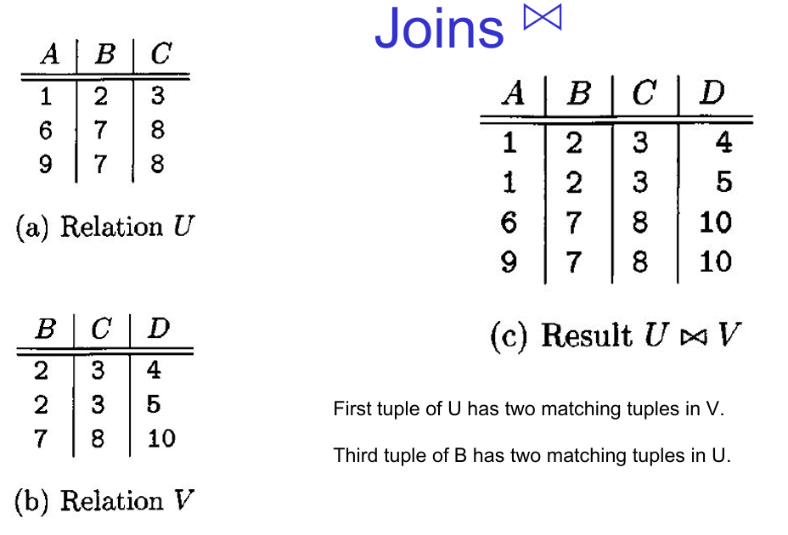

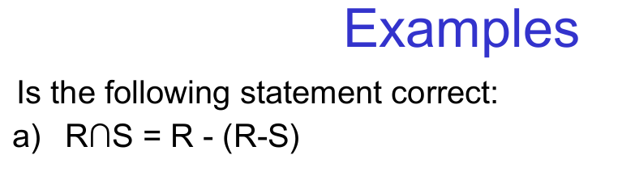

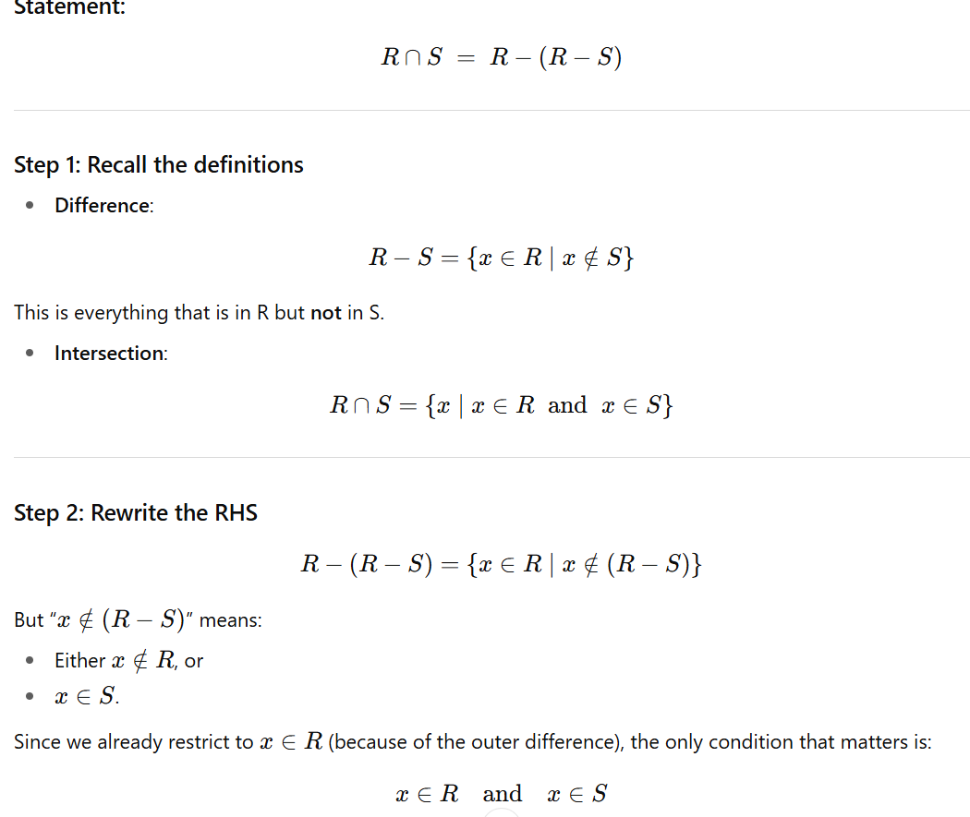
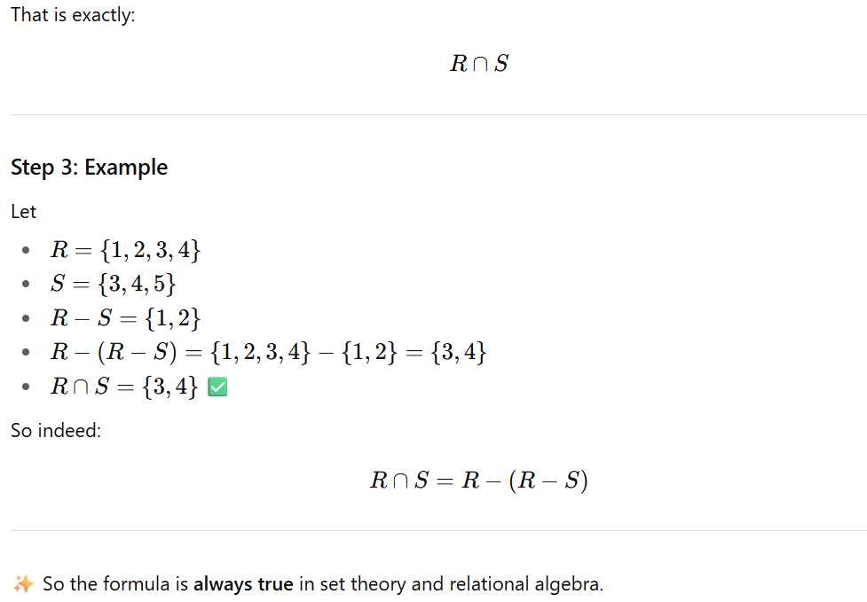

👉 also show the dual formula for union (like expressing R∪S using differences)?
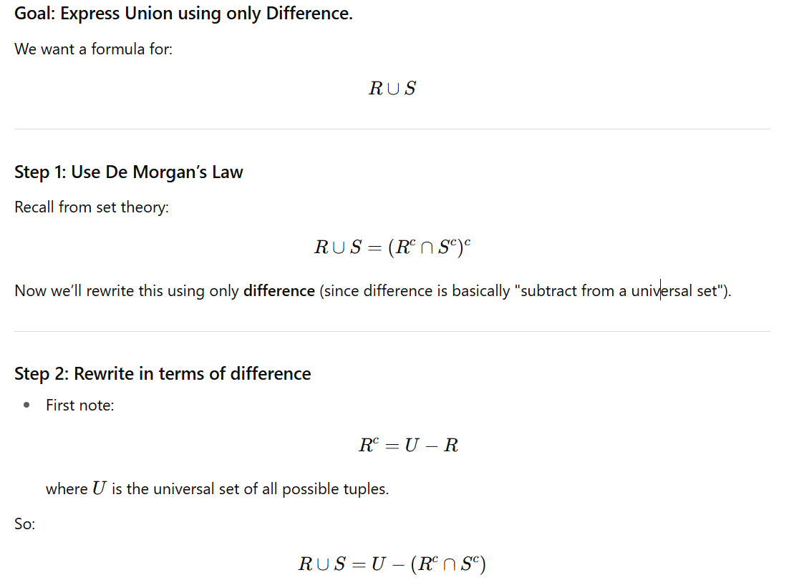
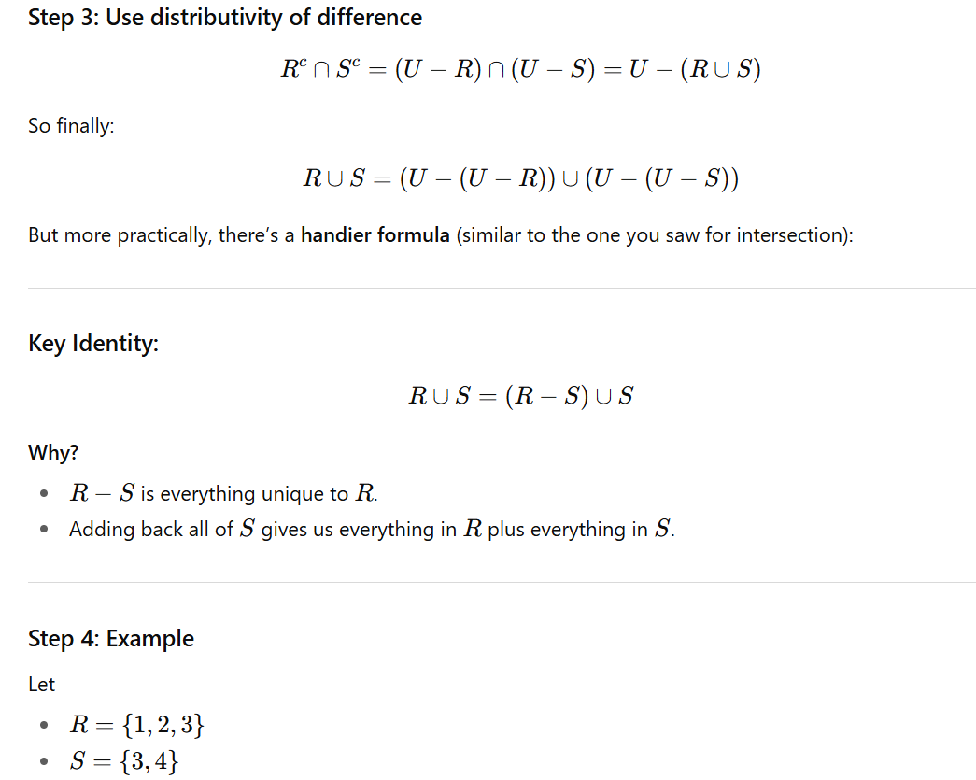
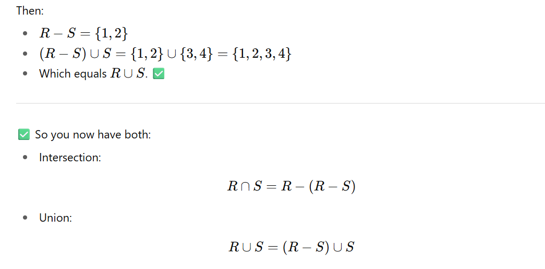

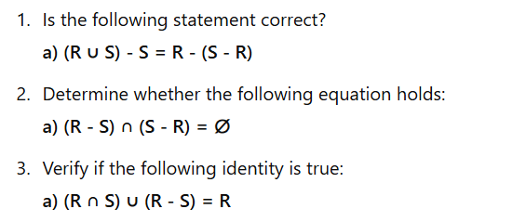

Let's prove each of the statements with set theory principles and provide examples.

Statement 1: (R ∪ S) - S = R - (S - R)
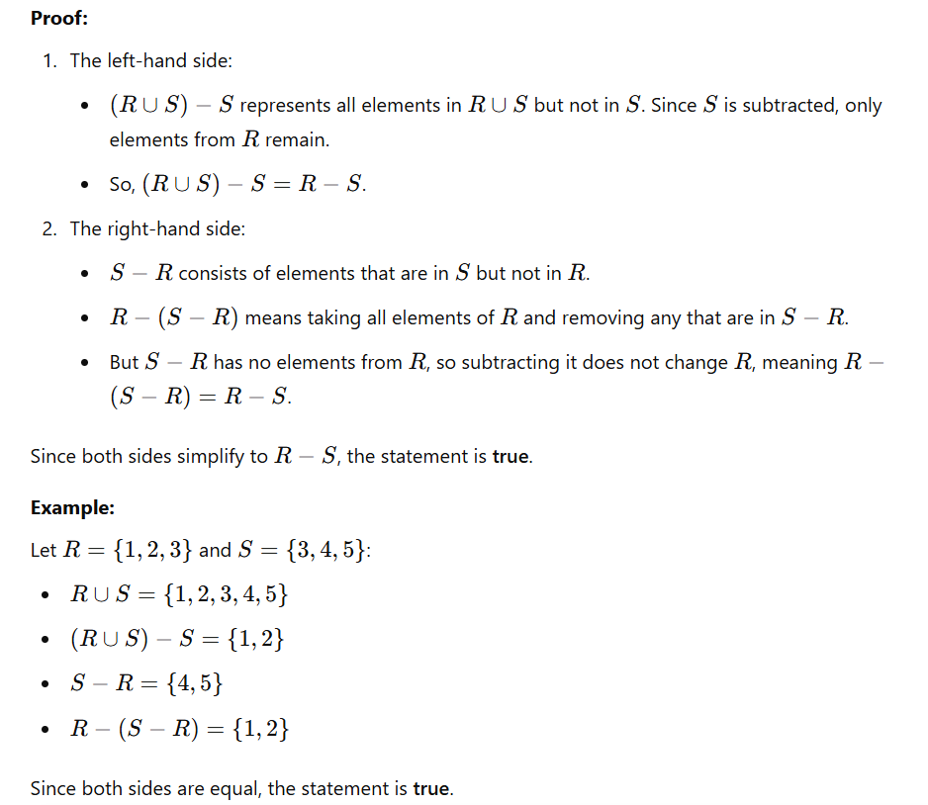

Statement 2: (R - S) ∩ (S - R) = ∅
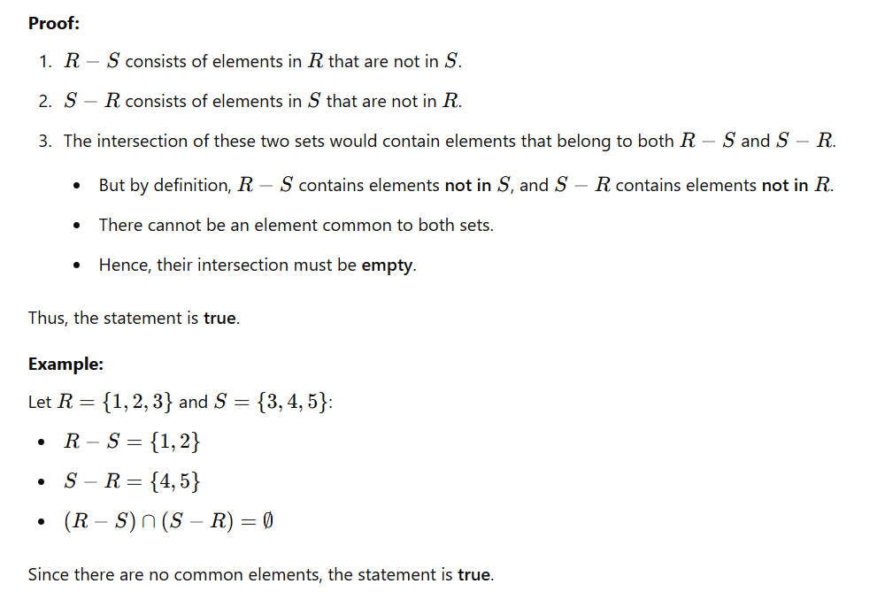

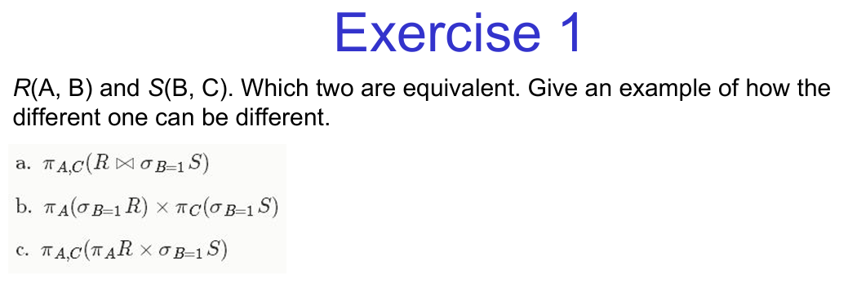
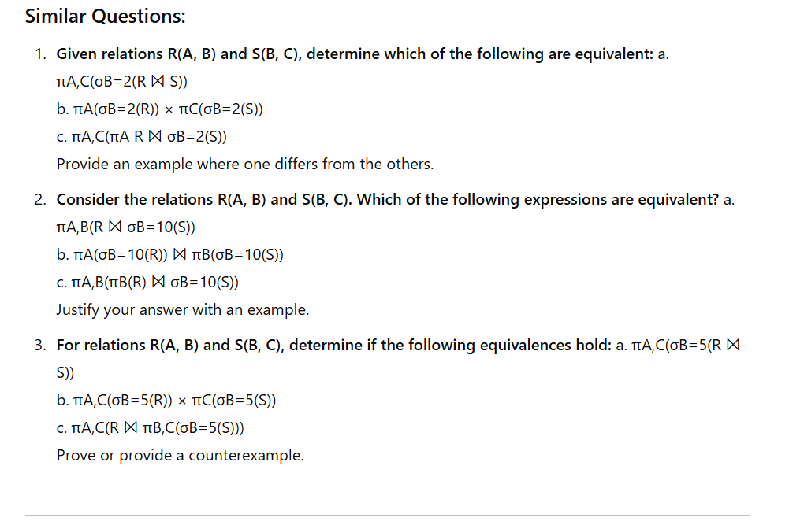
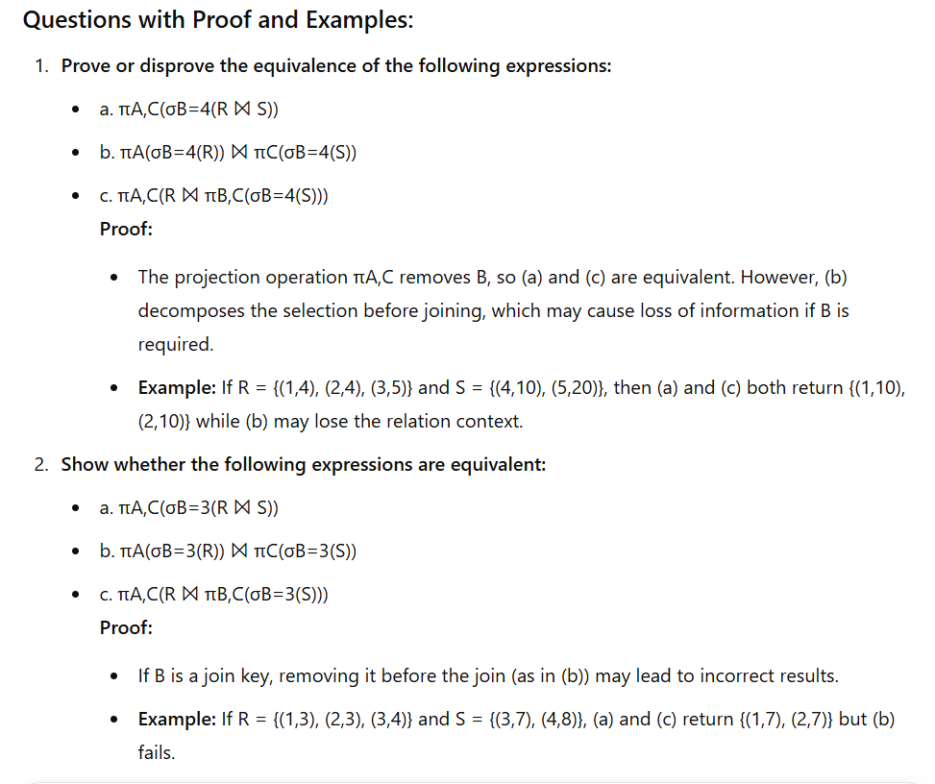
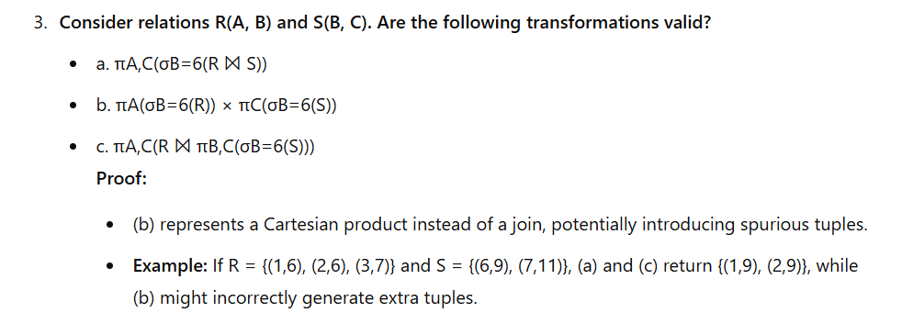

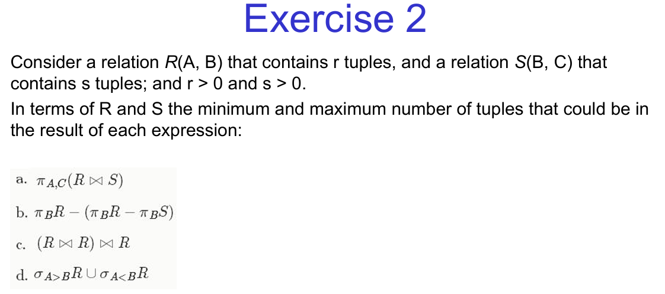

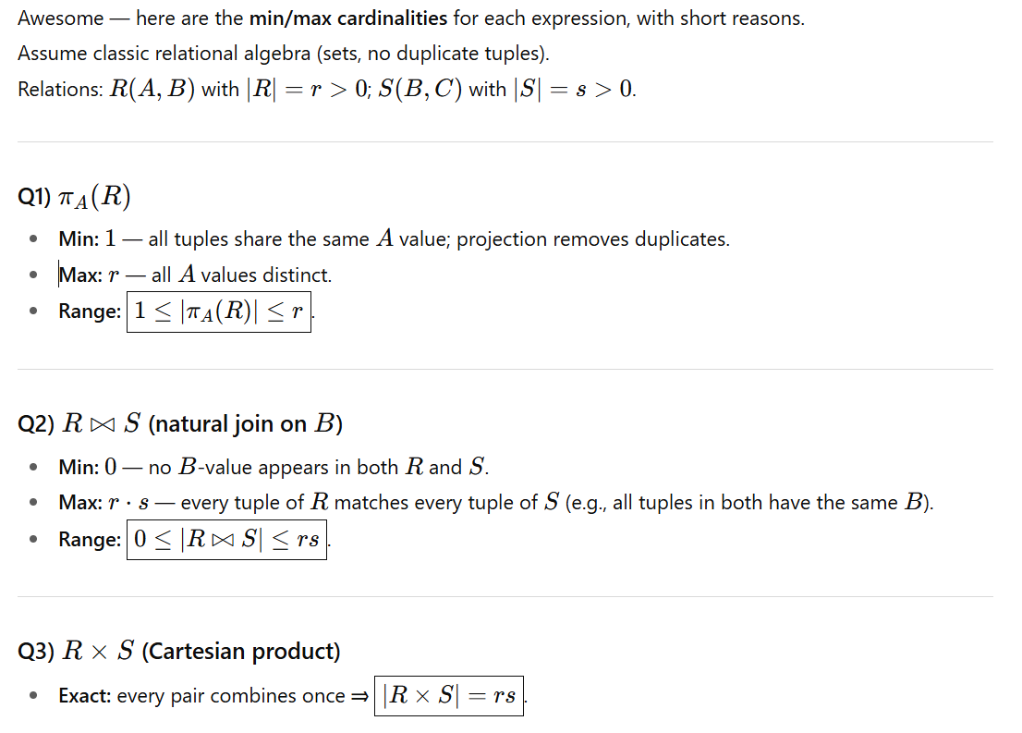
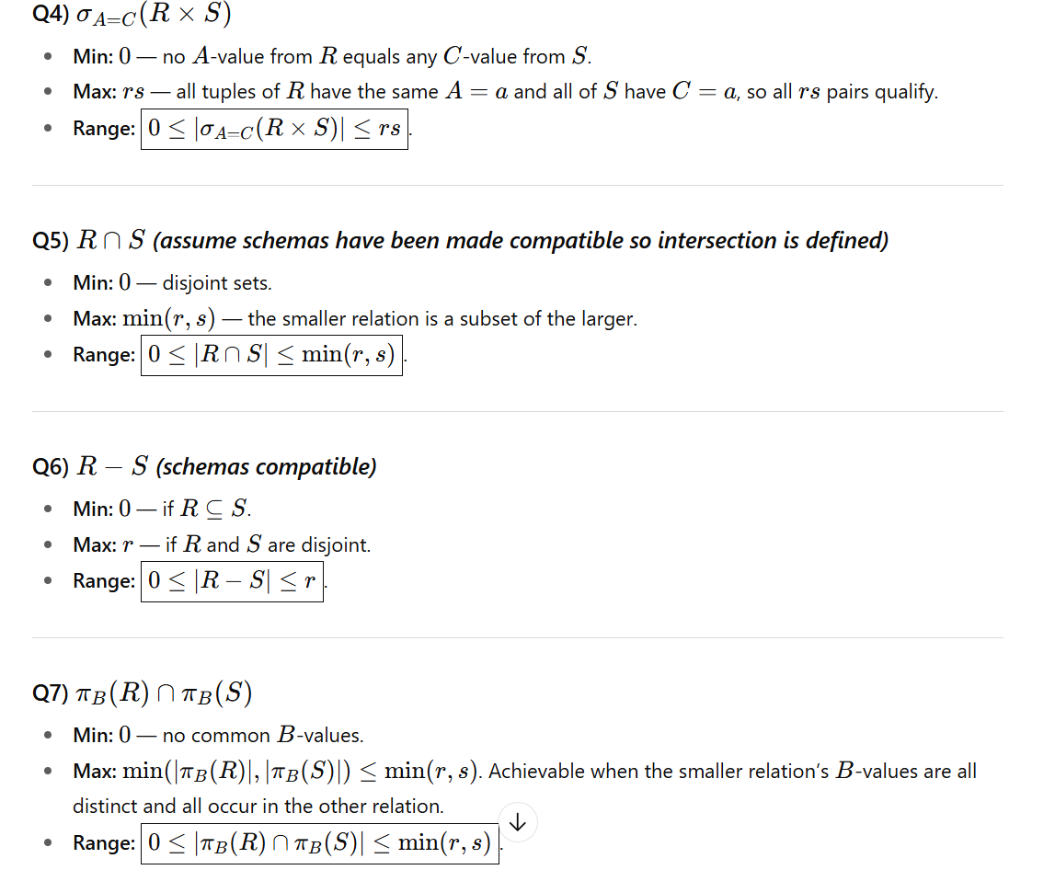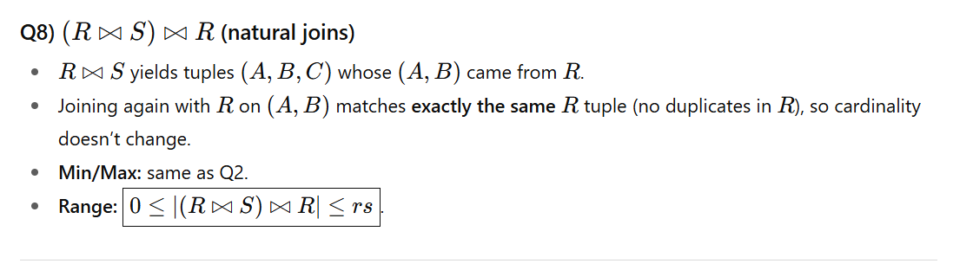

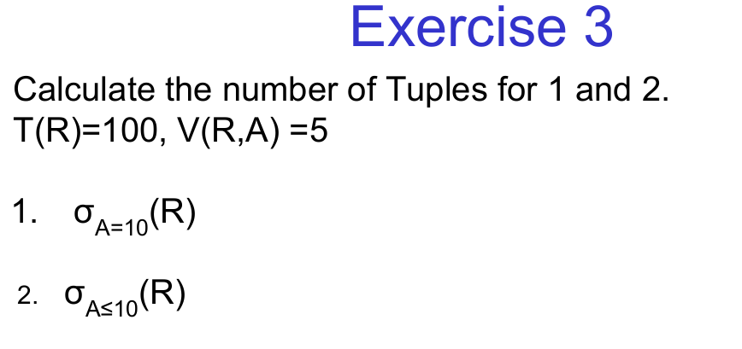
Three More with Proof and Examples: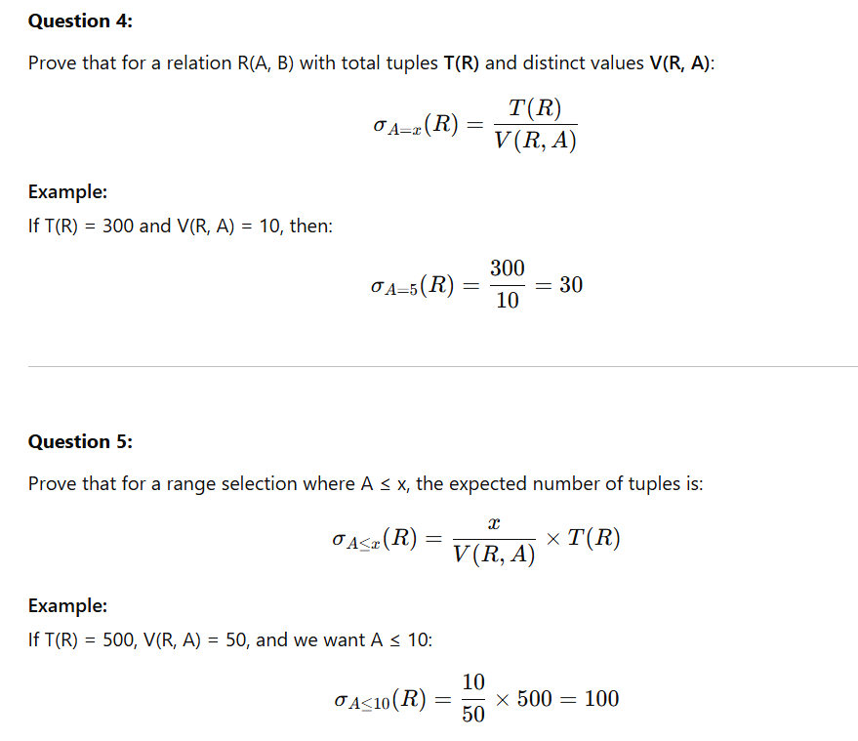
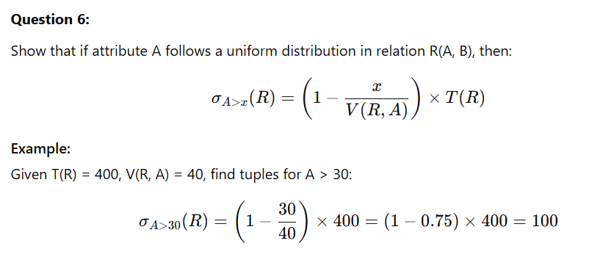
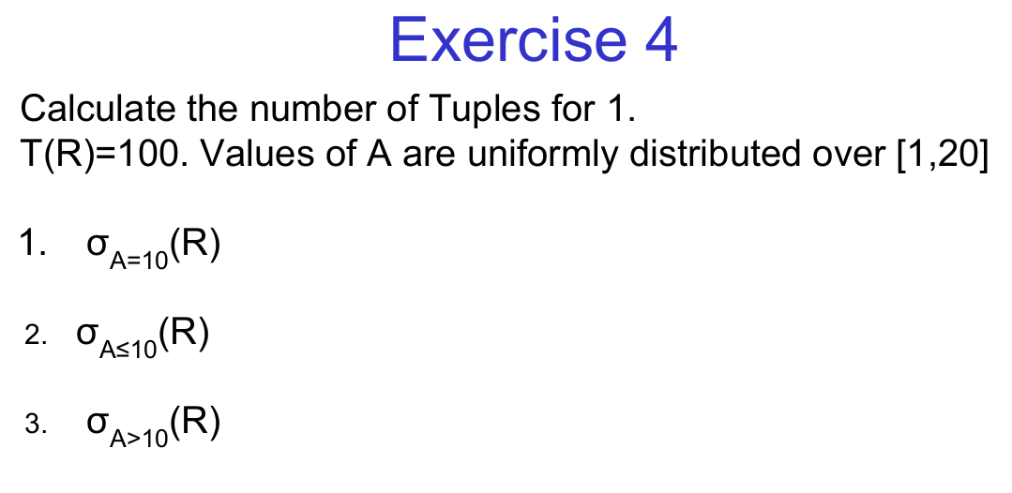
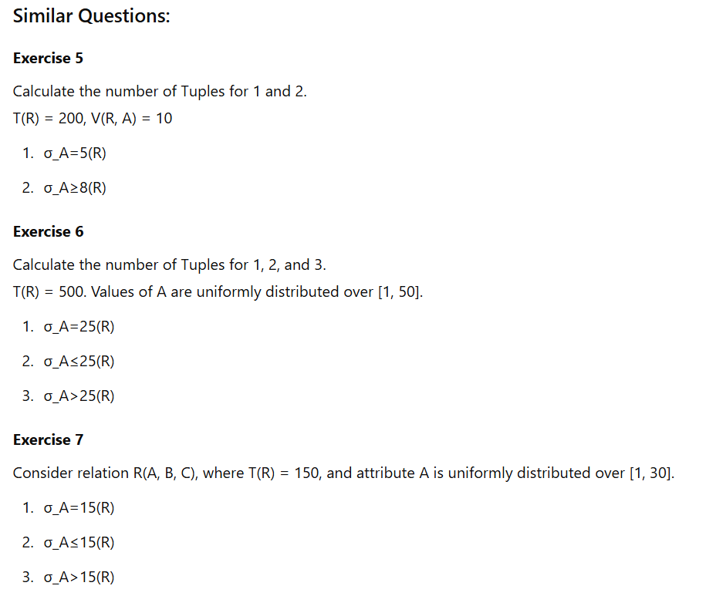
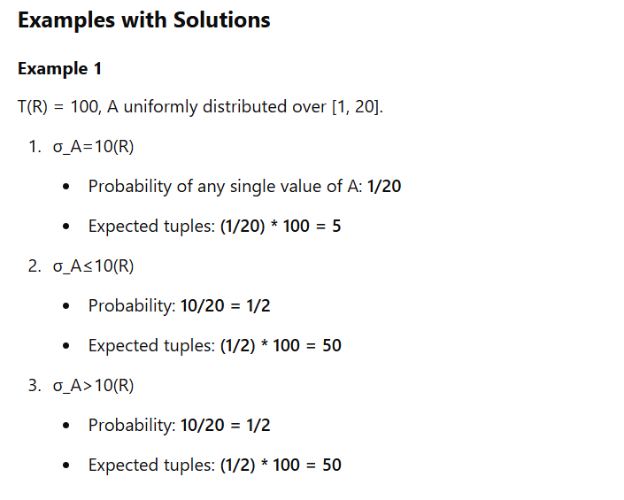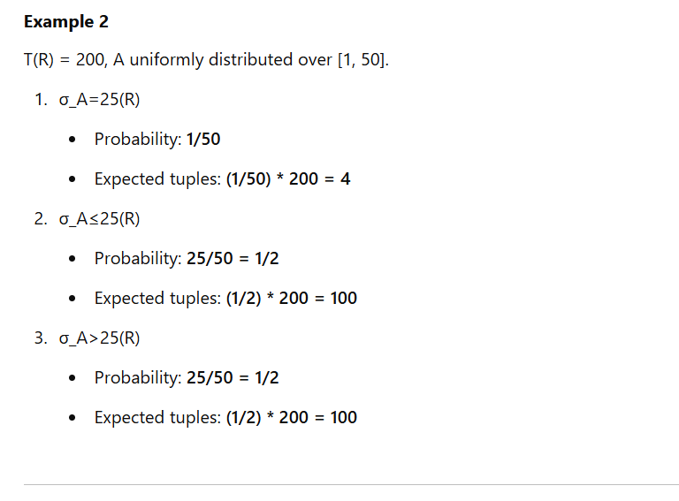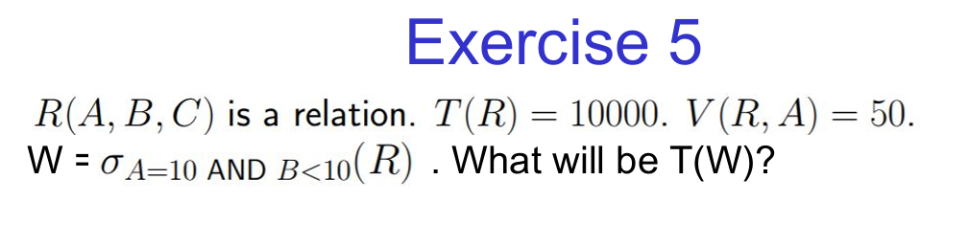
Similar Questions:
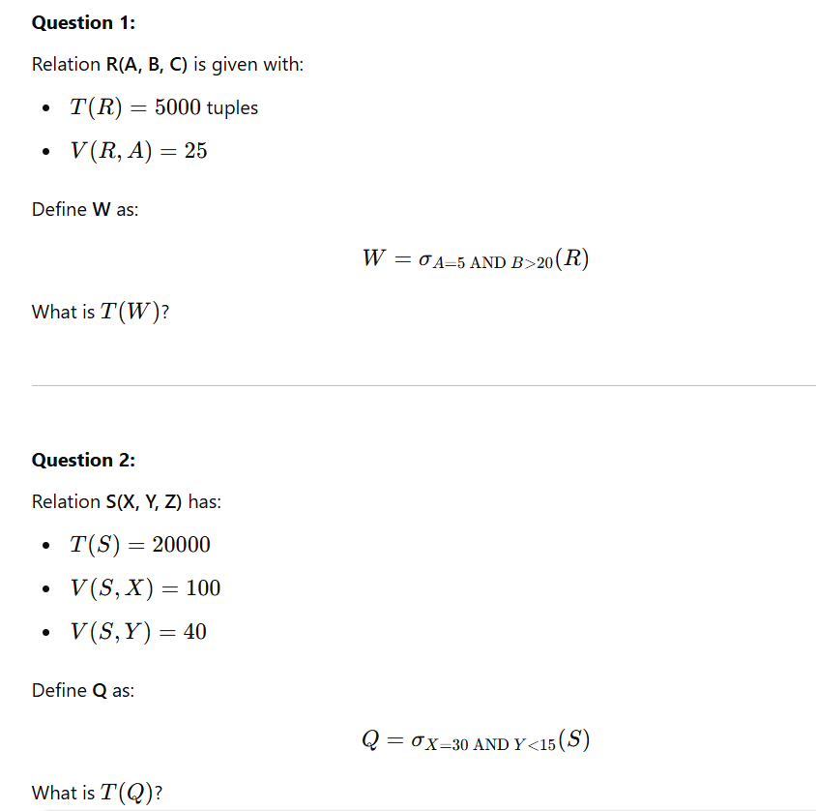
Examples with Solutions:
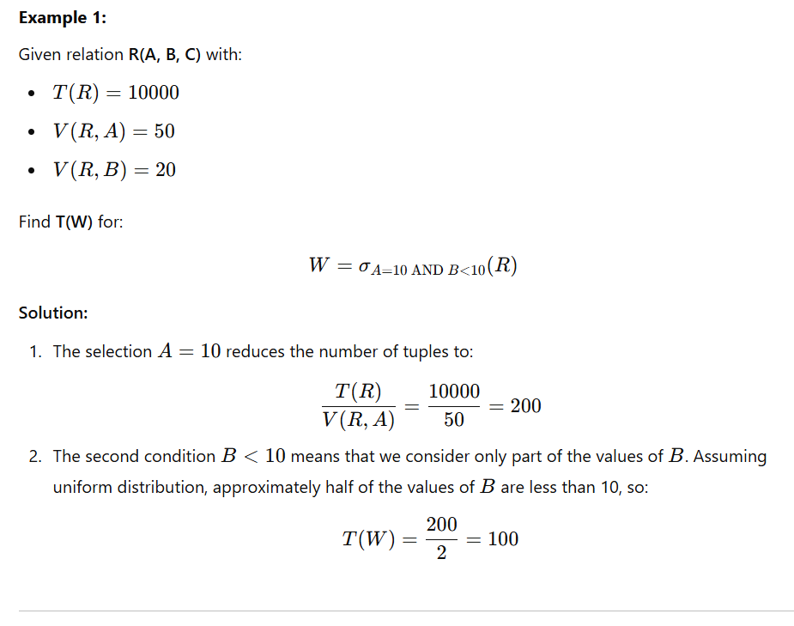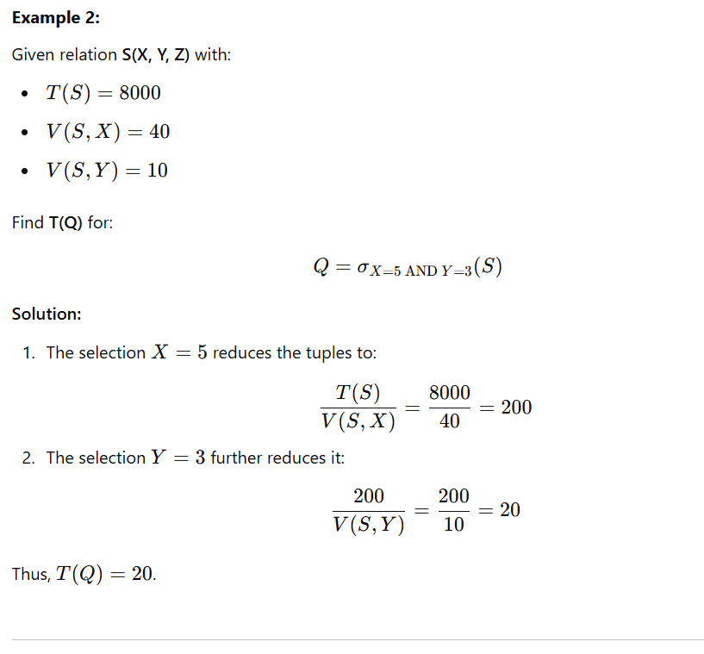
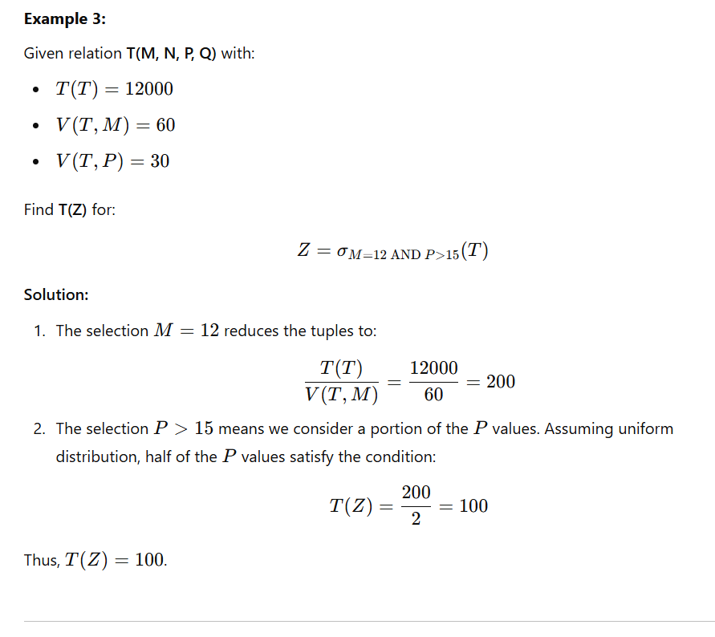

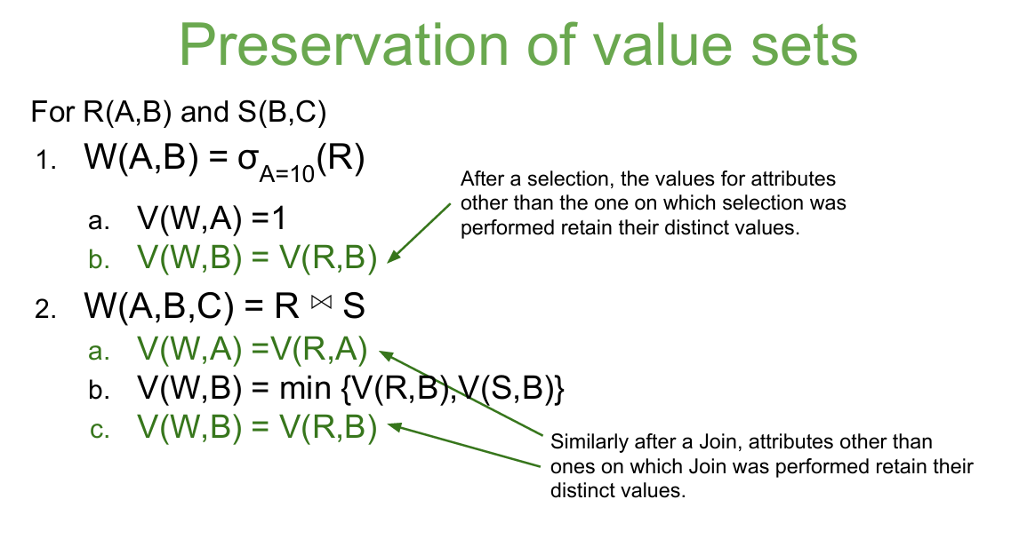
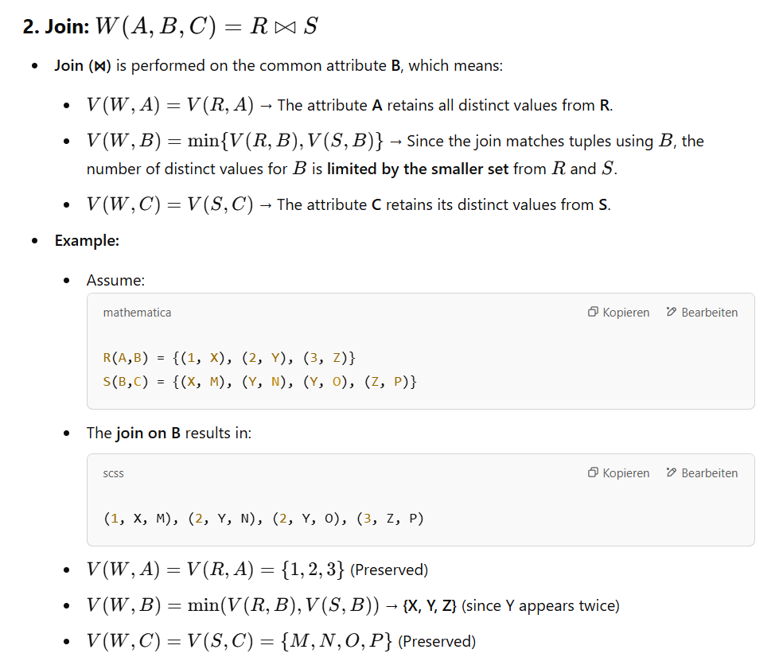
Conclusion
The Preservation of Value Sets states that:
- Selection retains all distinct values for attributes not used in the condition.
- Join preserves distinct values for non-join attributes but reduces values of the join attribute to the intersection of both relations.

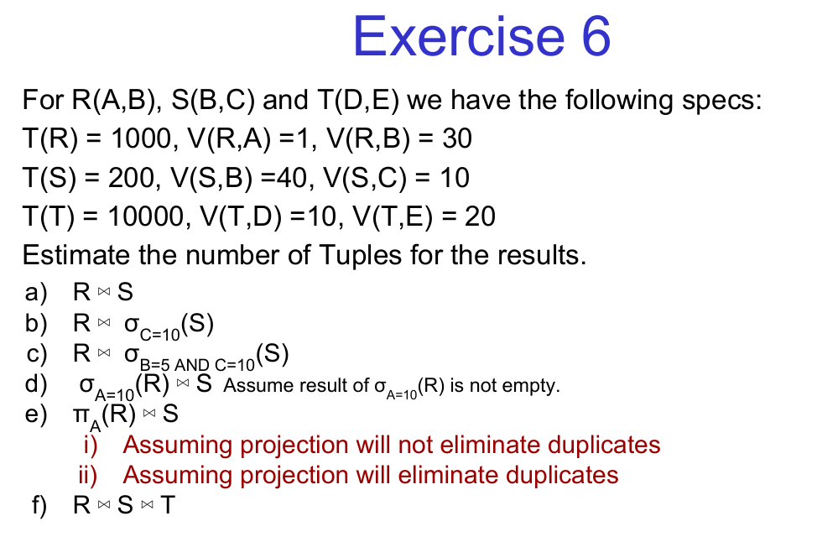
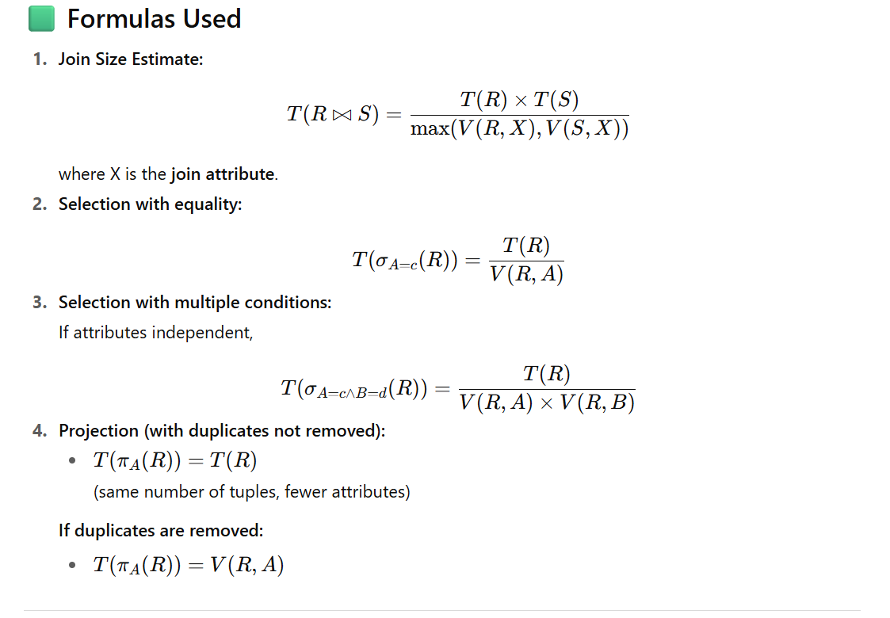

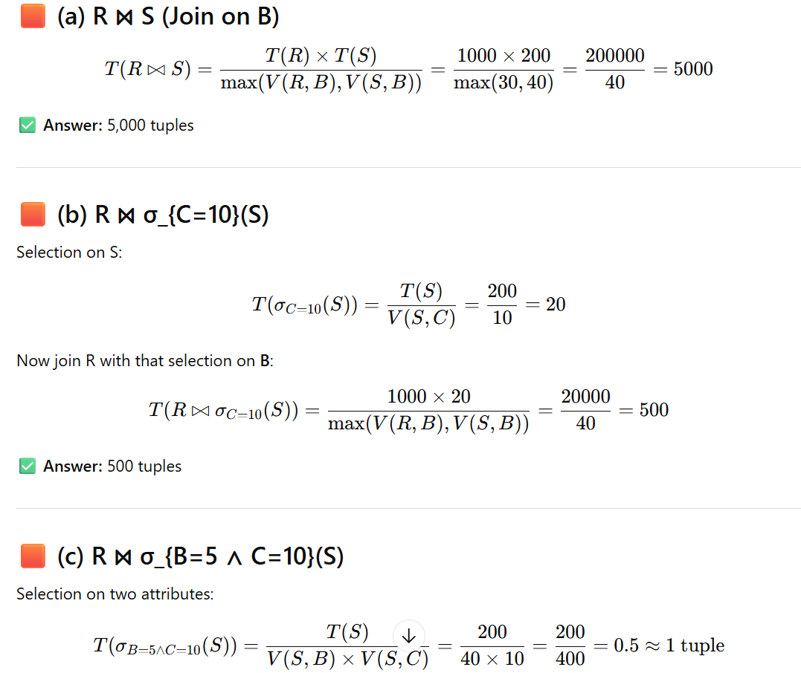
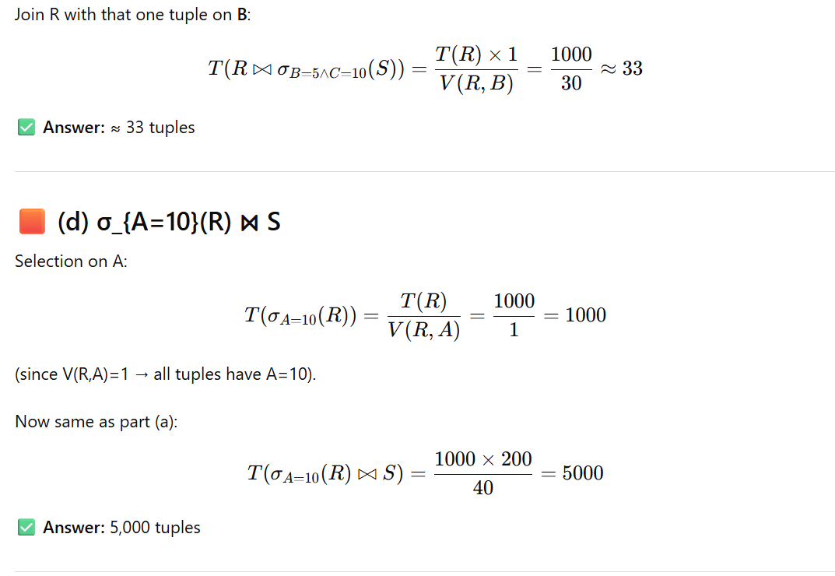
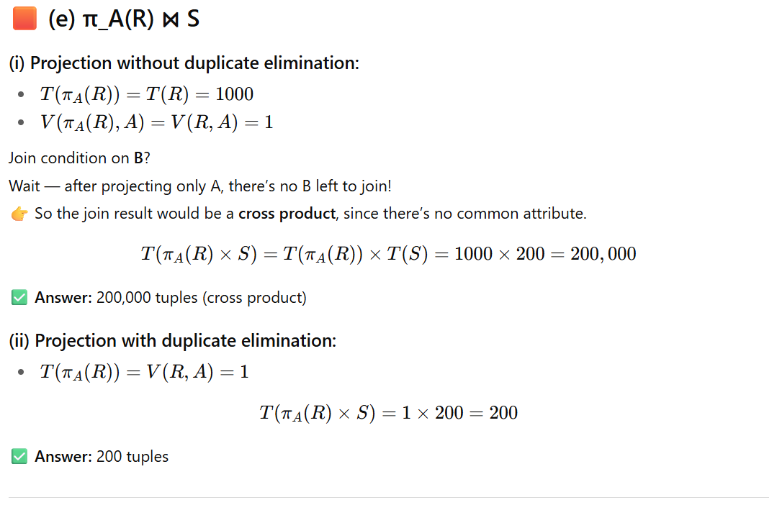
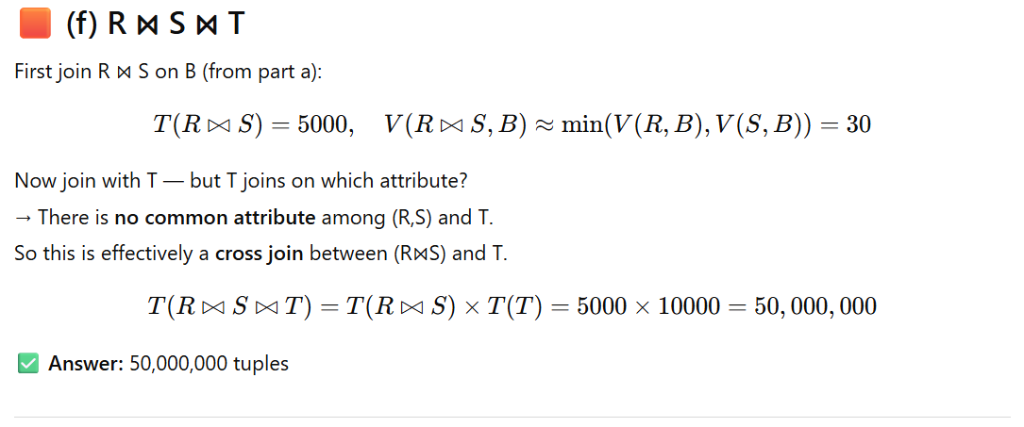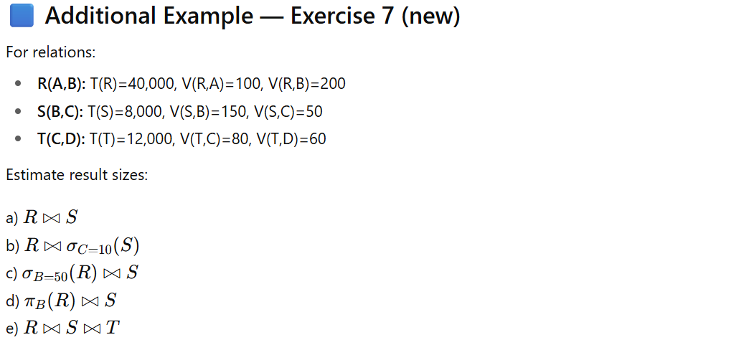

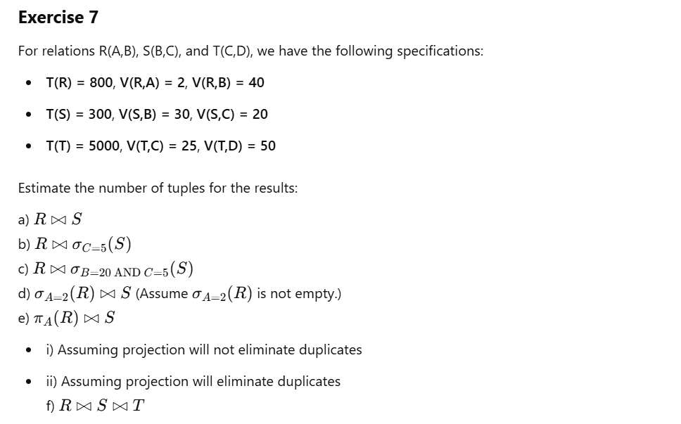
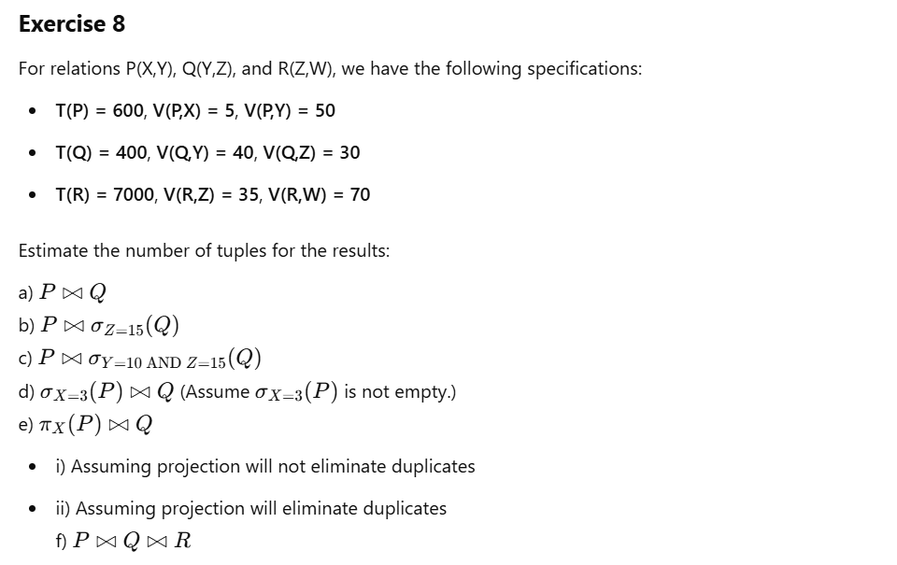

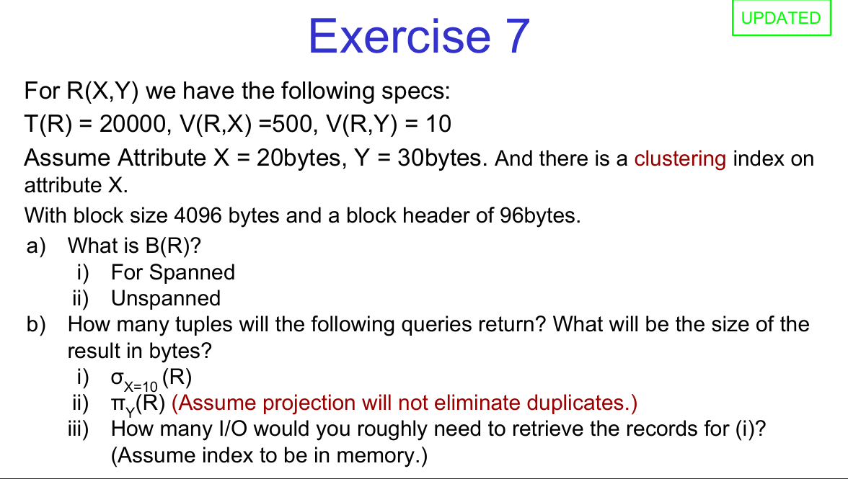

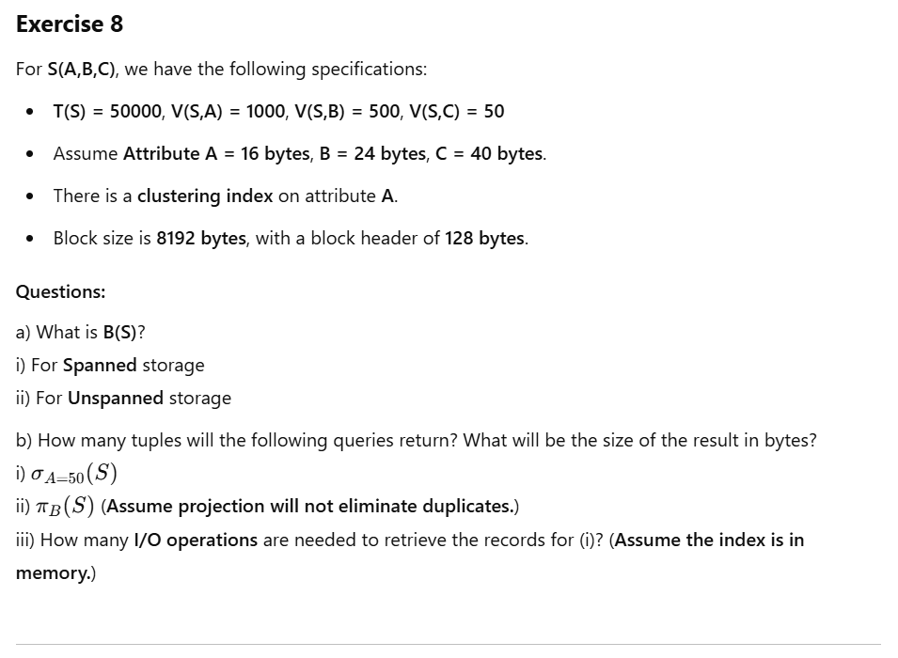
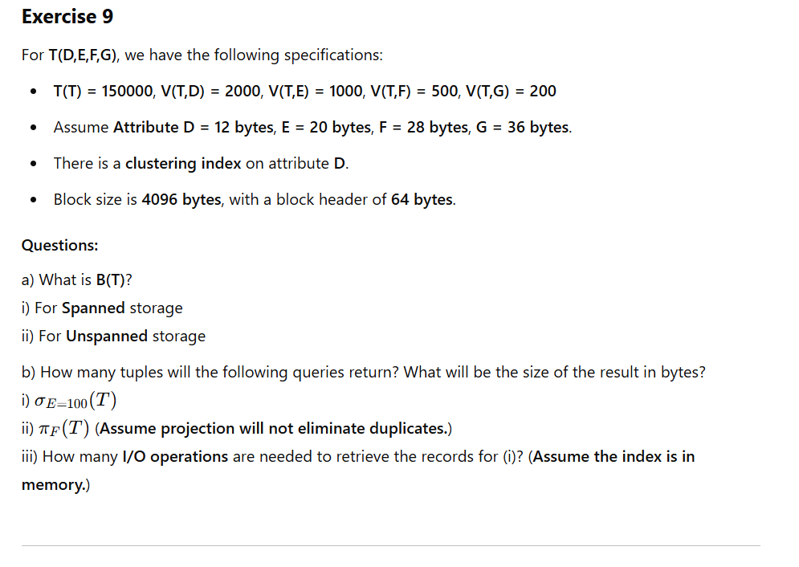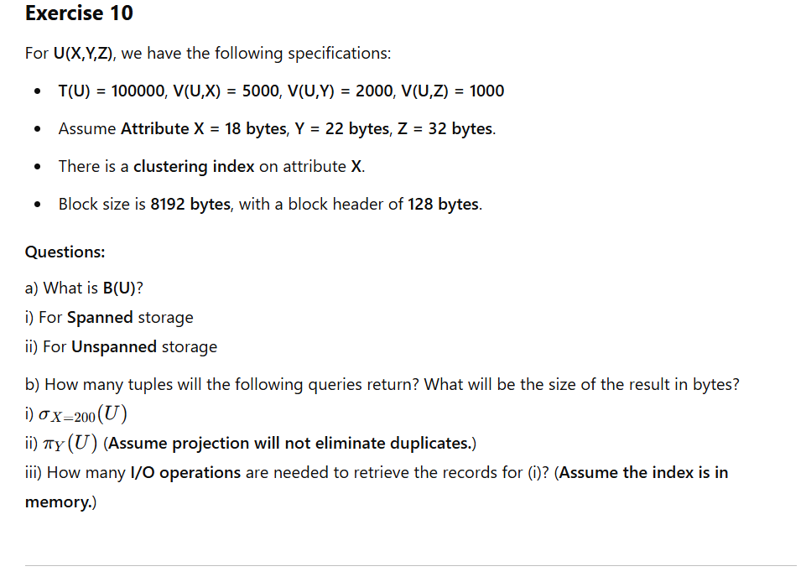

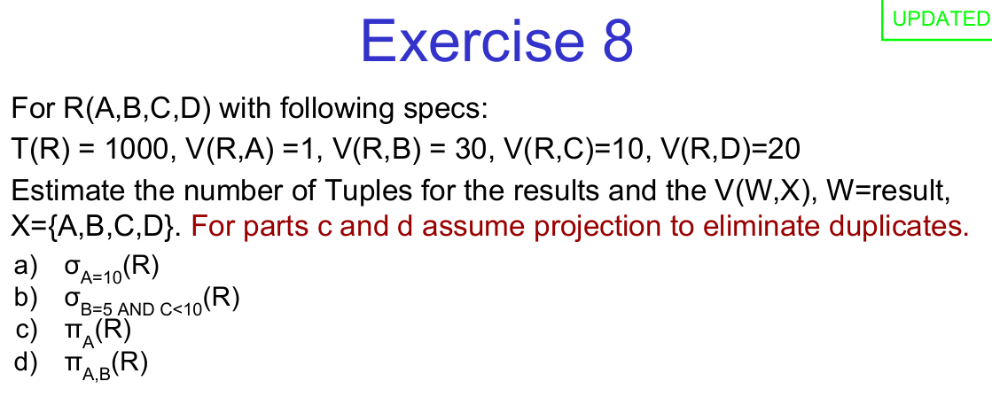
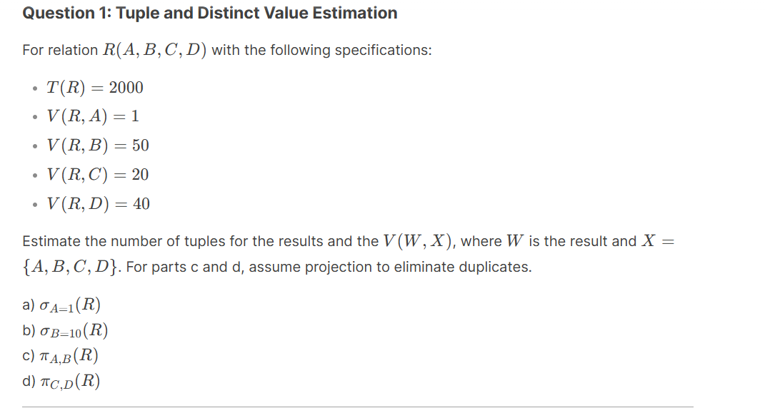
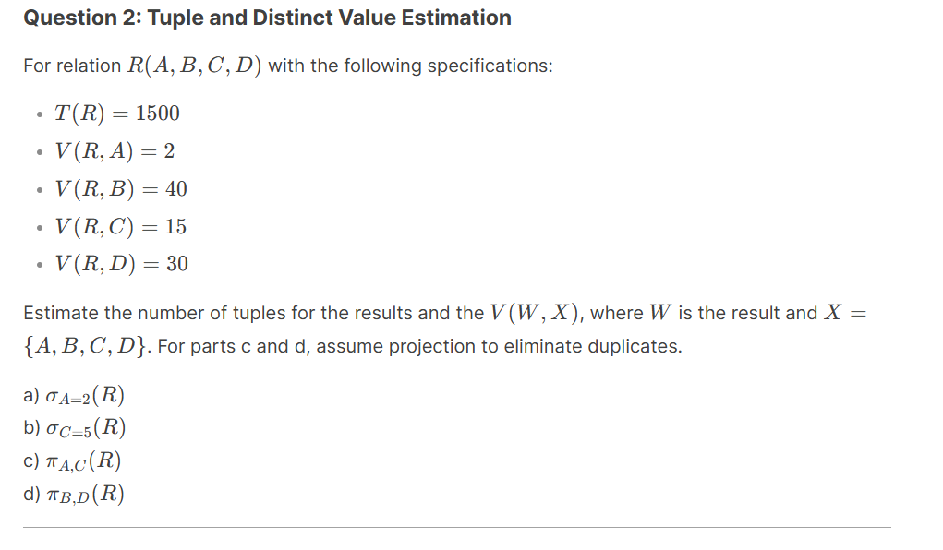
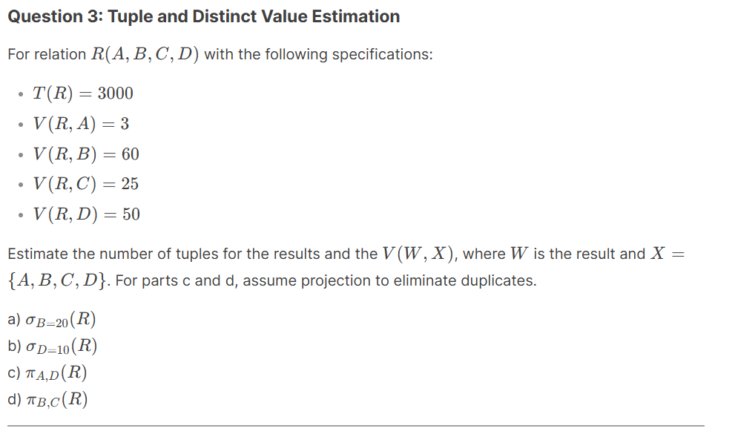
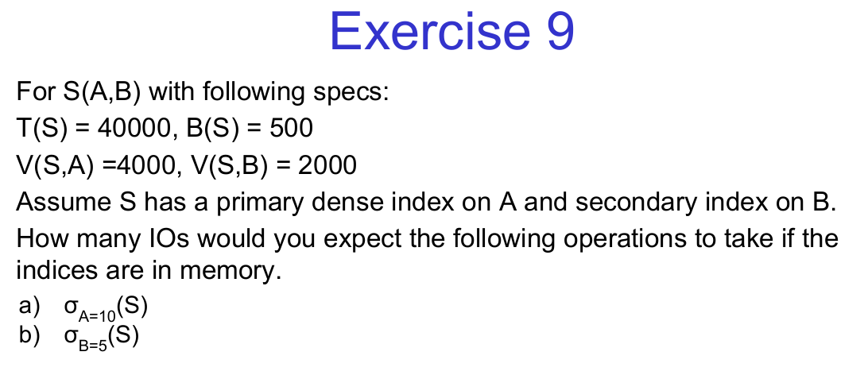
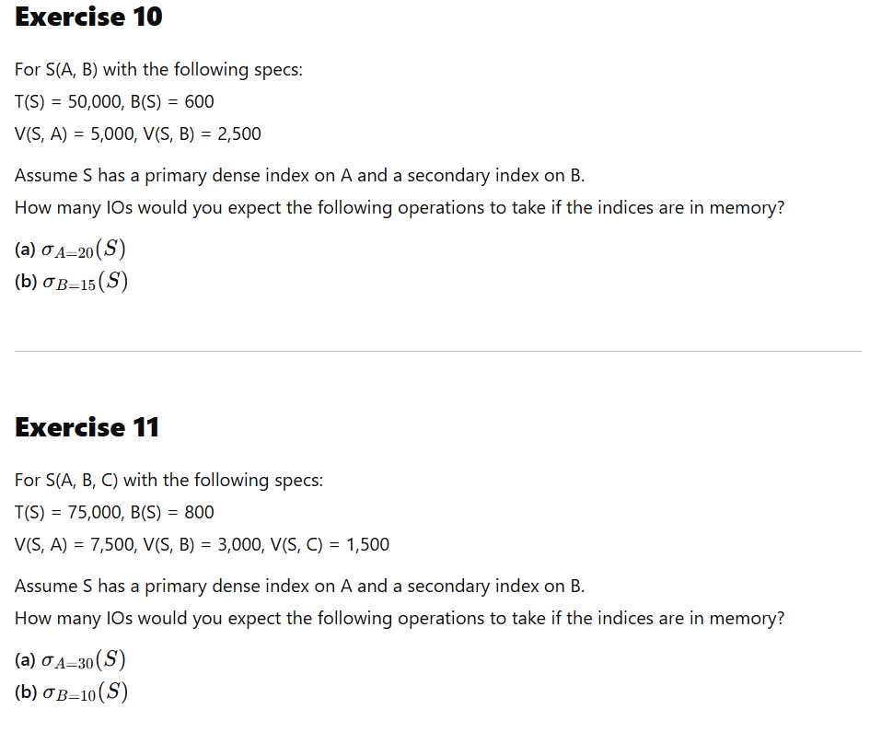
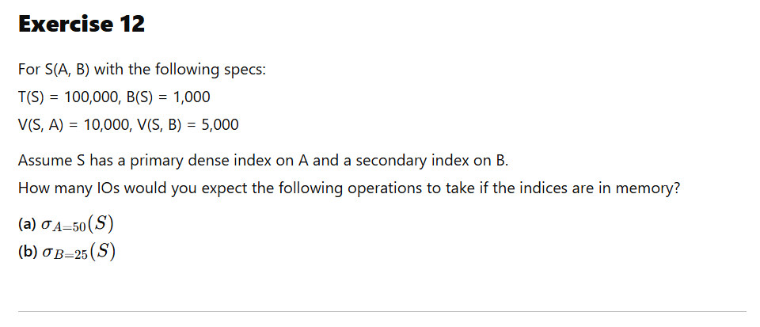
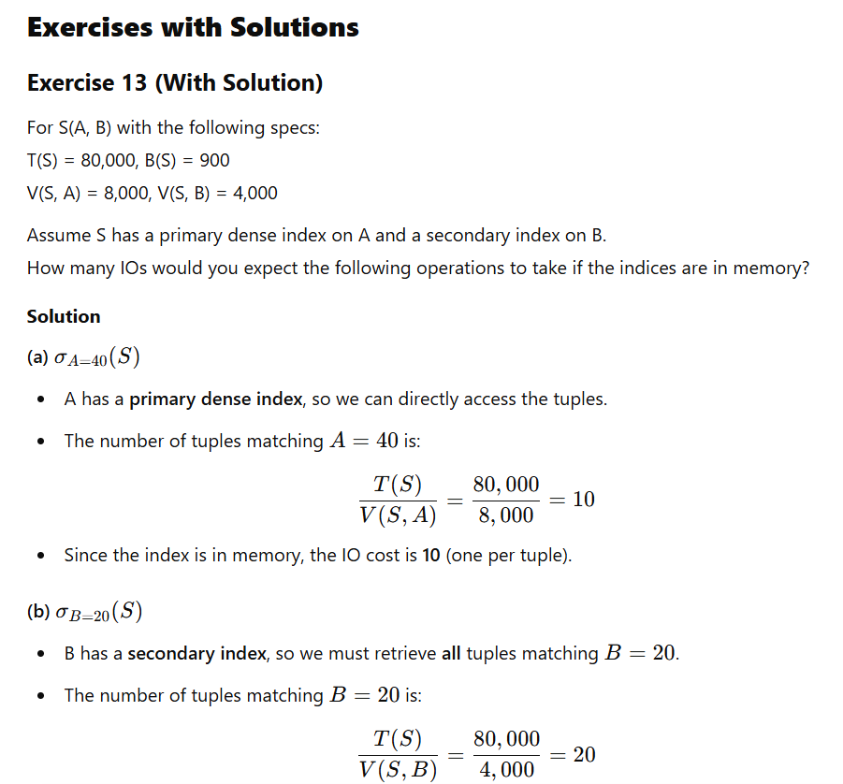
- Since the secondary index is in memory, each tuple access requires an additional IO.
- Total IOs = 20.

